Reading Success 1 Final Test
Units 21-40
A. Fill in the blank with the correct word from the box.
flows | weigh | charity | pocket | guess
clerk | measure | junction | sticky | hurt

- The bank ____________ handed me a form so that I could open an account.
- The ____________ raises money for poor people.
- Honey is a very ____________ substance.
- Can you ____________ my age?
- Please ____________ the room so I know what size rug to buy.
- I am so fat that I don’t want to ____________ myself—I’m too embarrassed.
- The water ____________ slowly out of the faucet.
- Jerry ____________ his foot when he stepped on glass.
- Turn right at the next ____________.
10. What’s that sticking out of your ____________?
B. Match the word to its definition.
1. highway | a. able to make money
2. rectangle | b. to continue
3. health | c. not high
4. profitable | d. a large road connecting two cities
5. go on | e. the body’s condition
6. need | f. a four-sided figure
7. kick | g. a type of metal
8. low | h. to strike out with the foot or feet
9. zinc | i. to require
10. earn | j. to make money

C. Read the passage. Rewrite the statement to make it correct.
The Wallet
I found a wallet in the street on my way to school a few months ago. There was some money in it but no name or address. I took the wallet to the police station. I told the police officer where I had found it and at what time I found it. I also gave him my name, address, and phone number.
The policeman called me today and asked me to come to the police station. When I got there, he told me that no one had come and asked for the wallet. He said I could have it. I thought about this. It was a good wallet, and I need a new one. However, I didn’t want the money. I said, “I’ll take the wallet, but please give the money to charity.”
The policeman said he was very happy to do this. I feel happy about it, too.

1. The writer found a wallet at school.
__________________________________________________________________
2. The writer knew whose wallet it was.
__________________________________________________________________
3. The police officer went to the writer’s house.
__________________________________________________________________
4. The writer didn’t need another wallet.
__________________________________________________________________
5. The money went to the writer.
__________________________________________________________________

D. Read the passage. Complete the flyer.
A Notice
There will be a meeting of the Chess Club at 1 p.m. on Friday, September 14, in the library. All members are asked to attend. New members are also welcome.
At the meeting, we will elect a new president for the club. Mary, our old president, will be moving to Ohio this month. The officers in the club will suggest people for other members to vote on.
Mr. White will give a talk on “How to Choose a Chess Set” and will show different kinds of chess sets.
Newton School Meeting
Who: ____________________

When: ____________________

Where: ____________________

Purpose of the meeting: ________________________________________

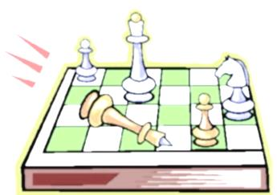
Speaker: ____________________ Topic: ____________________

Reading Success 1- Final Test AK
A.
1. clerk
2. charity
3. sticky
4. guess
5. measure
6. weigh
7. flows
8. hurt
9. junction
10. pocket

B.
1. d
2. f
3. e
4. a
5. b
6. i
7. h
8. c
9. g
10. j
C.
1. The writer found a wallet in the street.
2. The writer didn’t know whose wallet it was.
3. The police officer called the writer.
4. The writer needed another wallet.
5. The money went to charity.

D.
Newton School Meeting
Who: Chess Club members
When: Friday, September 14
Where: library

Purpose of the meeting: to elect a new president

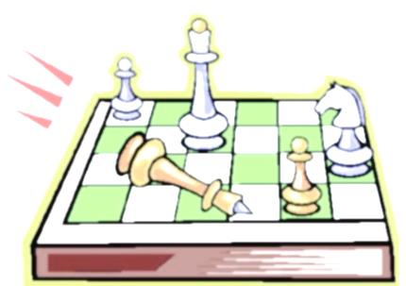Speaker: Mr. White
Topic: How to Choose a Chess Set

